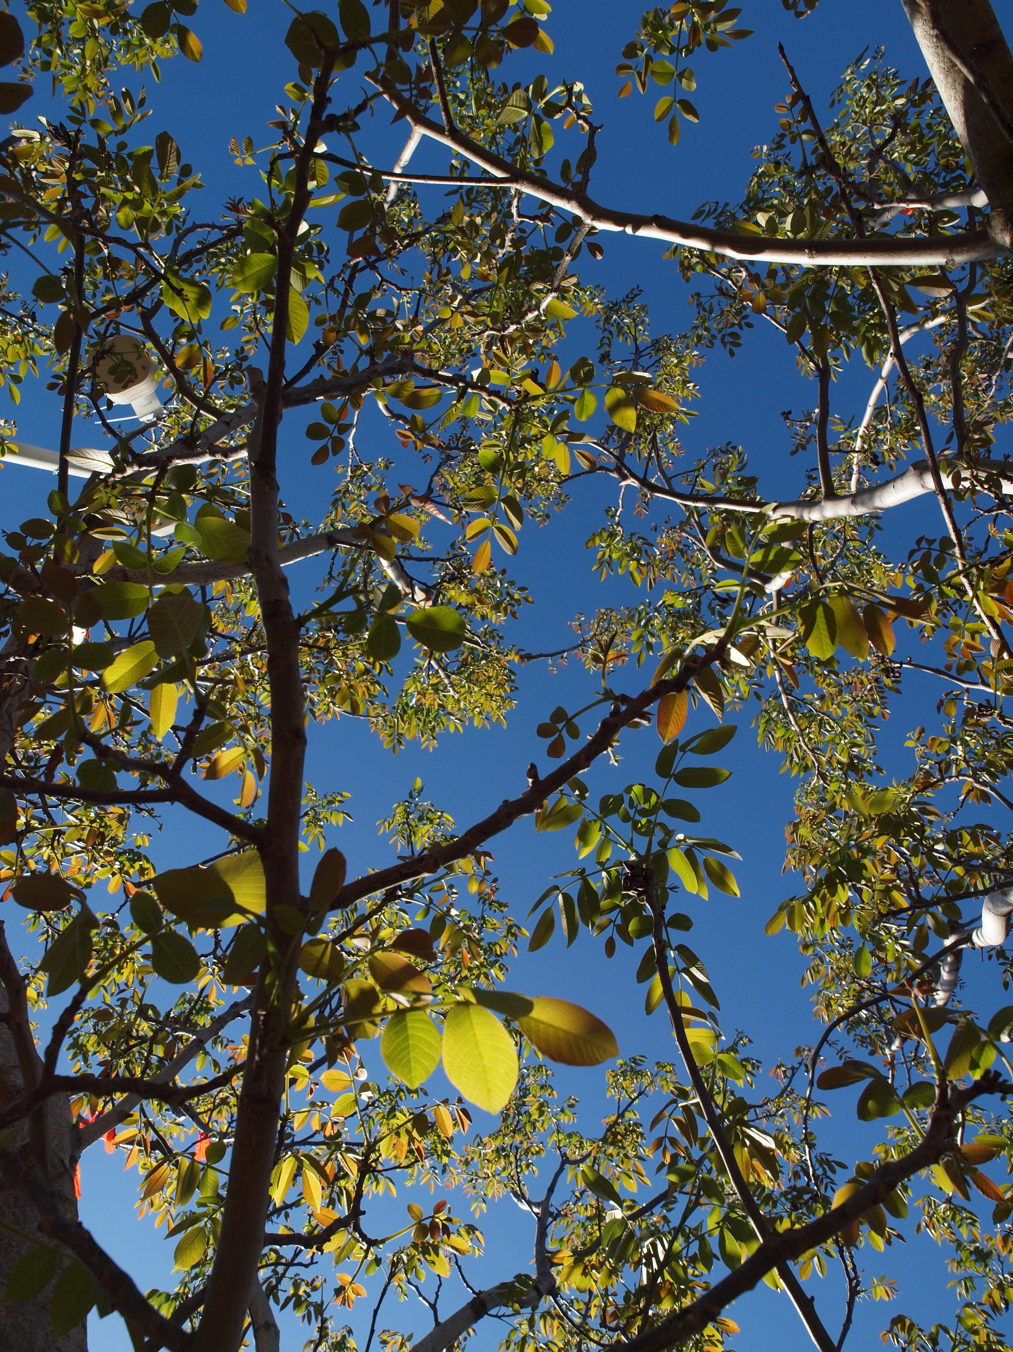

**UCCE Southern Sacramento Valley Walnut Meeting**

March 12, 2024

Norton Hall, 70 Cottonwood St, Woodland 8:00 am – 12:00 pm

1.0 hours of DPR CE hours requested (0.5 Laws, 1.0 Other)

**8:00 AM Laws & Regulations Update**

Molly Mathews, Yolo County Agricultural Commissioner’s Office

**8:30 AM Walnut Blight & Management**

Jim Adaskaveg, UC Riverside Plant Pathology

**9:00 AM Dormancy Breaker Research Update, Employee Training Feedback Session**

Kat Jarvis-Shean, UCCE Sacramento-Solano-Yolo

**9:40 AM Resource Conservation Incentive Opportunities Update**

**9:50 AM Break**

**10:10 AM Monitoring and Management of Key Pests of Walnut in the Sacramento Valley**

Sudan Gyawaly, UCCE IPM Advisor

**10:30 AM California Walnut Board & Commission Update**

Robert Verloop, CEO California Walnut Board & Commission

**11:00 AM Panel Discussion: Industry Update & Issues**

**12:00 PM Adjourn**

